**Application#:**

**CONVERTING NUMBERS TO WORDS**

1. **Introduction**
2. **Assumptions**
3. **Future scope for enhancements**
4. **Simple Design**
   1. **JavaScript/HTML Application**
   2. **SOAP XML Request over HTTP**
   3. **SOAP XML Response over HTTP**
   4. **Web Service (.asmx)**
5. **Validations**
6. **Solution Submission**
7. **Introduction**

The requirement is to take the inputs name and number from the user, and output the name and number converted in to words by invoking a web service. As per the given requirement understanding develop a User Interface client application (using HMTL hand Java Script) call the Web Service. Develop a web service, which converts a number in to words. It takes a decimal number as input and converts each individual digit to its equivalent word.

1. **Assumptions**

As it was mentioned in the “About Your Solution” to develop a web service, and a front end java script application

* 1. As per the understanding of the requirement mentioned, it is to develop a web service with .asmx extension. The scope doesn’t cover any WCF Service or a Web API.
  2. The UI part is done in JavaScript and HTML elements as the assumption it was asked to develop only in JavaScript.
  3. The numbers are considered from a range of 0 to 99999999999999.99 as the scope by looking at the example requirement.
  4. The name data is only for displaying purpose it doesn’t seems to be having anything to do in relation with the web service.
  5. As it was asked to display both name and number, assumed that both are mandatory for the user to enter.

1. **Future scope for enhancements**
   1. Allow the signed numbers like **+** (**PLUS**) or **–** (**MINUS**) in converting the numbers
   2. Add the currency symbols and comma separators
   3. The Web Service can be used in customized “Calculator Application” to display the calculated figures in works
2. **Simple Design**

Below is a simple design of how the communication happens between the User Interface JavaScript/HTML application and the Web Service

**JavaScript /HTML Application**

**Web Service (.asmx)**

SOAP XML Response over HTTP

SOAP XML Request over HTTP

* 1. **JavaScript/HTML Application:**

The User Interface application caters the below

* + Should be provided with the User Interface input elements for capturing the Name and Number.
  + Apply the validations for verifying whether the input given is valid data.
  + Format the number input as a SOAP XML request, by providing the web service URL, header, body, input details in the envelope and send the XML Http request in a JavaScript to the web service.
  + Display the result output, where a number converted into words from the web service in the User Interface.
  + Sample User Interface looks like the below screen.

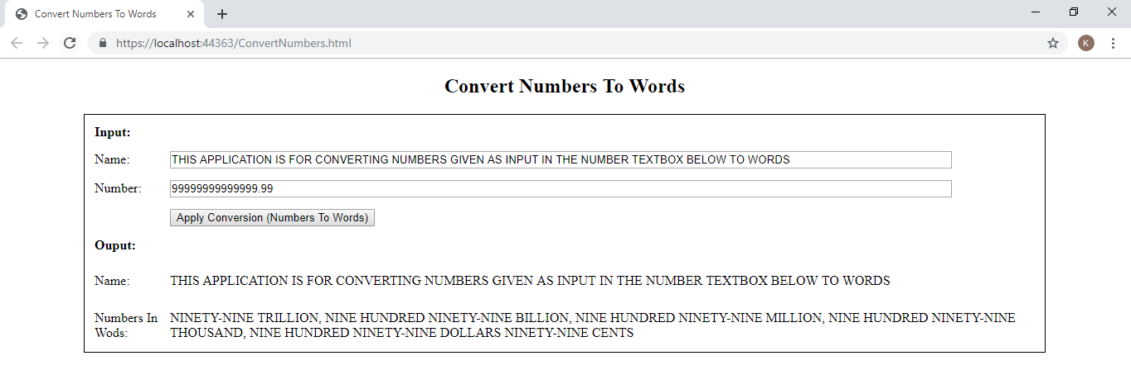

* 1. **SOAP XML Request over HTTP**
  + A SOAP XML request has to be formatted by providing the web service URL, header, body, input details in the envelope to send it to the Web Service.
  1. **SOAP XML Response over HTTP**
  + Output is returned in a SOAP XML response where the result has to be parsed and displayed in the User Interface Application.
  1. **Web Service (.asmx)**
  + The Web Service has to be implemented using the .Net Web Service with an .asmx extension, which takes a number as input and returns the output result in words.

1. **Validations**

Apply various validations in the User Interface to pass a valid input to the Web Service.

* + Verify if the Name is a required and must be filled out.
  + Verify if the Number is a required and must be filled out.
  + Verify if the given Number is an invalid number.

1. **Solution Submission**
   * The code was developed using Visual Studio 2019 community edition. Hope it doesn’t violate any corporate policy, if it was run in the company premises.
   * As I understand, it may just need to update the below URL path of the web service, as the port number may vary, if at all required. I believe it’s not required.

xmlHTTP.open("POST", "https://localhost:44363/ConvertNumbersToWordsService.asmx", true);